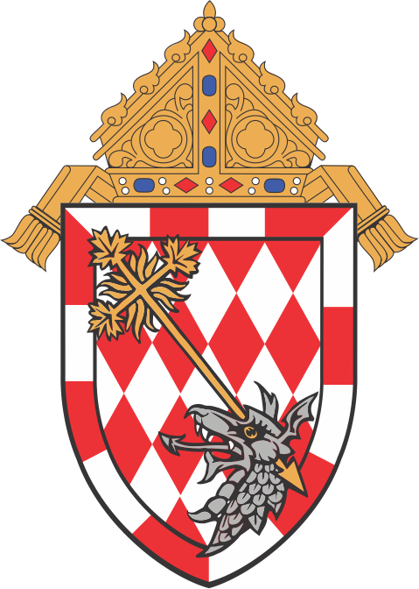

Parish Information
I currently live within the territorial boundaries of the parish.
I currently do not live within the territorial boundaries of the parish, but I am formally registered at the parish.
City:
Name of Parish:
First Holy Communion Registration Form
Please complete this form and return it to the parish (PLEASE PRINT)

Child's Information
Date of Baptism:
Church of Baptism:
Address of Baptismal Church:
First Name Middle Name(s) Last Name
Female Date of Birth: City of Birth:
Male
Full legal name of child:

Parent's Information
Phone: Email:

I am a parent of, or have legal custody of the child.
Postal Code
City
Street
Same as mother's
Present Address:
None
Religion: Other:
Last Name
Middle Name(s)
First Name
Roman Catholic
Phone: Email:

I am a parent of, or have legal custody of the child.

Father (Full legal name):
Postal Code
City
Street
Present Address:
(Maiden Name)
None
Other:
Last Name
Middle Name(s)
First Name
Roman Catholic
Religion:
Mother (Full legal name & Maiden Name):

Declaration
Date:
I, the undersigned, declare that the information on this form is true and accurate. Name (PLEASE PRINT):
Signature:

